SPANISH 2 FALL FINAL OUTLINE

Auditory Comprehension (5 points, multiple choice)
- 1-minute recorded listening passage in Spanish
- multiple-choice comprehension questions in English

Benefits of Bilingualism (4 points, multiple choice)
- multiple-choice questions in English
- professional, social/cultural, and cognitive benefits of bilingualism

Describing Personality (5 points, multiple choice)
- English to Spanish translations
- Conjugations of ser, agreement of adjectives
Ex. I am impatient.
A. Estoy impacienta. B. Estoy impaciente.
C. Soy impaciente. D. Soy impaciento.

Daily Routines & Reflexive Verbs (5 points, multiple choice)
- Caption the image with a sentence describing the daily routine action
- Reflexive pronouns and reflexive verb conjugation
Ex. A. Se cepilla la cara.
B. Se lava la cara.
C. Se cepilla los dientes.
D. Se peina los dientes.

Expressions with Infinitives (5 points, multiple choice)
- English to Spanish translations
- Expressions such as ir + a and tener + que
Ex. Can you speak more slowly please?
A. ¿Podes hablar más despacio, por favor?
B. ¿Podes hablas más despacio, por favor?
C. ¿Puedes hablar más despacio, por favor?
D. ¿Puedes hablas más despacio, por favor?

Preterite (5 points, multiple choice)
- English to Spanish translations
- Regular preterite verbs
- Irregular verbs such as ir, ser, estar, poder, tener, hacer, decir, traer, and poner
Ex. I went to the store.
A. Fui a la tienda. C. Fue a la tienda.
B. Foi a la tienda. D. Ié a la tienda.

Comparisons (5 points, free response in Spanish)
- Given an image of two people or things, write five sentences comparing them.
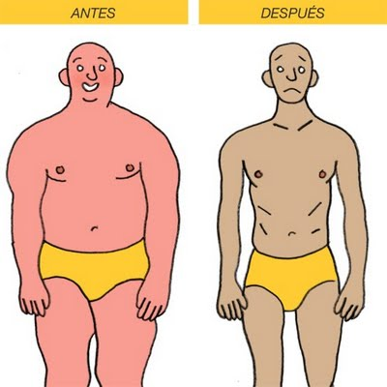
Ex.
Use the image to write five sentences in Spanish comparing the images from before and after. For example: Which is happier? Which is more serious? Who is skinnier? Who is darker? Who is fatter?

Basic Greetings & Introductory Verbs (5 points, fill in the blank)
- Fill in the blanks of a dialogue in Spanish
- Basic greetings (¿Cómo estás? ¿De dónde eres? etc.)
- Present-tense verb conjugations
Ex. MARCOS: ¡Hola! ¿______________________________?
PABLO: Estoy bien, gracias.

Reading Comprehension (6 points, free response in English or Spanish)
- One-paragraph reading in Spanish
- 3 free-response questions about main ideas and author’s purpose

Introductory Essay (10 points, one-paragraph essay in Spanish)
You will have two options for the essay. They will be based on the following essential questions.
- ¿Cómo eres? What’s your name? Where are you from? How old are you? What is your family like? What do you like to do? What is your daily life like?
- ¿Cómo te preparas? What is your daily routine like? How do you get ready in the morning? What do you do before and after school? What time do you eat your meals? When do you go to bed at night?

2nd period final: Tuesday, December 15 at 8:35 am
4th period final: Tuesday, December 15 at 10:40 am

